|  |  |
| --- | --- |
|  | |
| Tech spec for Loan Approval System |  |
|  |  |
| **Owner:** | **Management** |
| **Created on:** | **December 26, 2019** |
| **Document ID:** | **LMS-TDS-001** |
| **Document type:** | **Business** |
| **Version:** | **1.0.0** |

|  |  |  |  |
| --- | --- | --- | --- |
| **Revision information** | | | |
| Rev. | Author | **Date** | **Description** |
| Draft-1 | Md. Muzibul Hoque | Dec 26, 2019 | Initial doc creation |
|  | Md. Kamruzzaman | Dec 22, 2019 | Contributor |
|  | Kawsar Mia | Dec 23, 2019 | Contributor |
|  |  |  |  |

|  |  |  |  |
| --- | --- | --- | --- |
| **Related documents** | | | |
| Sl# | Document ID | **Document name** | **Comments** |
| 1 |  | Functional requirement document |  |
| 2 |  | API Request / Response document |  |

# 1 INTRODUCTION

## 1.1 Purpose

The purpose of this documents is to define the functional and technical requirements of the developing application. This document is used to gain agreement with stakeholders and to provide a foundation to communicate to a technology service provider what the solution needs to do to satisfy the customer’s and business’ needs.

## 1.2 Scope

The scope of the application is to manage loan processing and to create a convenient and to easy-to-use for bank employee. Business recommendation and approval can be managed by in-house user. Furthermore, loan applications can be imported from multiple channels like branches and online portal.

Initially, this developing system will be designed only for police account holders. In future external customer’s loan will also be included. And its scope is defined from loan application form collection with supporting document to loan sanction process. Later on, loan repayment, classification and interest provision calculation can be incorporated.

## 1.3 Background

Community bank has committed to establish a software for loan management process so that they can minimize the work effort by reusing exiting data. At present, these commitments are difficult to achieve due to the manual working process. This consumes time as operation teams need to manually manage loan process and customers are impacted.

# 2 FUNCTIONAL REQUIREMENTS

## 2.1 Context

### Current Manual Workflow Diagrams



Definitions, Abbreviations and Acronyms: The abbreviation & different symbols used in the document will be incorporated as below :

| **Term/Acronym** | **Definition** |
| --- | --- |
| LMS | Loan Management Solution |
| CBBL | Community Bank Bangladesh |
| naztech | nazdaqTechnologies |
| CAD | Credit Admin |
| BM | Branch Manager |
| CIB | Credit Information Bureau |
| SO | Source Officer |
| CRM | Credit Risk Manager |
| CBS | Core Banking System |
| MIS | Management Information System |
| nSCREEN | Sanction Screening Software |
| BP No | Bangladesh Police Number |
|  |  |

# 3 Technical Document Contents:

The followings will be included in the SRS document as below:

## 3.0 TECHNICAL DETAILS

## 3.1 BASIC CONSIDERATION AND DEPENDENCIES:

In the basic design of both modules, we considered the following standards:

* During system study, it was observed that the client has already some software running including CBS application which is maintaining by them. As most of the data are related with this CBS, so in the technical design, there is a scope to integrate this LMS with existing software application. The communication method with these application will be held through web API (HTTPRequest & HTTPResponse).
* The software reports will be generated into English language only.
* Strong data entry validation and constraint will be used to develop the system.
* All date fields will be formatted as: 31-12-2019. Years will always be presented in four digits. The only exception is the financial year, where the second part is displayed using two digits. E.g. 2019-20.
* In many situations, the way the data is presented in the form, is different from the way the data is stored in the DB. For this purpose, SQL view can be generated in exactly the same structure in which the data is presented in the UI.
* Considering the presence of existing software it is decided that the following interfaces are required to complete the current phase work scope :

1. User Login
2. Main Menu
3. Employee Info
4. Create User
5. Access Right
6. Document Uploading
7. Collateral Security
8. Guarantor
9. Insurance
10. Document Verification
11. Approval Process
12. Loan Policy / Rule
13. Loan Interest Rate
14. Contractual Interest Rate for loan

## 3.2 ACTIVITY PROCEDURE :

Considering the existing CBS application LMS will operate simultaneously.

According to the client’s operational structure, the software operated in three different levels.

* Field Level
* Branch Level
* Head office Level

Field levels (SO) are the basic sources of information at grass root level. They will collect applicant’s application form. Fill up the application with manually signed, all documents, etc. submit to branch office. In this level.

Branch office reviews collected documents and send to SO if needed for any missing documents. After getting all documents, SO creates a recommendation sheet and check CIB reports. After checking all required documents, they will send to Head Office CRM section.

* Head office CRM-MIS section will collect filled–up forms and other relevant documents from the branch office. They will review and allocate to an analyst. CRM-Analyst analyses and create an approval sheet mentioning sanction amount, EMI, interest rate etc. and send to CRM-Approver. The CRM-Approver(s) can approve, conditionally approve, decline recommend to another approver or return again to CRM Analyst. CAD section. CAD section print the sanction letter for disbursement.

Users of the system should be able to manage information based on role-permission. The system will support different type of user privileges to maintain the whole process in the software. The user should be able to do the following functions.

* **System Admin:** This user can maintain user and system configuration.
* **Business Admin:** This user can maintain business configurable items.
* **Applicant:** This user can create, update and send application to source officer/branch using online portal by login into the system.
* **SO:** This user can view application, create information form and find CIB report from credit admin (CAD). Further this user can create, update and send a loan recommendation sheet to Document verifier/branch manager.
* **Document Verifier:** This user can upload any supported documents/file of the applicant and then forward the loan recommendation sheet to Branch manager.
* **Branch Manager:** This user can review the loan recommendation sheet and then forward to CRM department.
* **CRM-MIS:** This user can receive the loan recommendation sheet with all attached documents and allocate it to analyst.
* **CRM-Analyst:** This user can analyze the loan recommendation sheet and all documents and then create an approval sheet to set actual loan amount, EMI and interest rate. After then user can submit the approval sheet to approver.
* **CRM-Approver:** This user can accept or reject the application and can notify to CAD department. Also this user can recommend to another approver.
* **CAD:** This user can provide CIB report to source officer. Also this user can print a loan sanction letter if CRM-Approver accept the loan approval sheet.

## 3.3 SECURITY LEVEL:

Currently in no app is used field level, in future apps can be developed and implemented. In the proposed system, there will be several user groups who will have individual access level. In this document it will describe Actor Roles on each & every level of the software operation. For example:

* Also this user can recommend to another approver.
* Ly Some users are allowed only to view data
* Some users are to make reports for the system
* Some users are to enter some administrative data
* Some users are to change dynamic data for limited cases but not allowed to change any administrative data

To perform all these tasks, the developed system has five level protection distinguishes users into HOAdmin, HOUser, BOAdmin, BOUser and Administrator

* **HOAdmin** : They are allowed to view and change all data of all branches and allowed to make central bank reports for all branches. They are not allowed to change any data.
* **HOUser** : They are allowed to view data and to make reports for all branches. They are not allowed to change any data.
* **BOAdmin** : Allowed to view and change all data of their own branch. This includes the branch configuration, static / dynamic data entry, report send to HO for their branch etc.
* **BOUser** : Allowed to view all data of their own branch. Allowed to enter / change regular transaction data only.
* **Administrator**: Allowed to change all data of all branches. It is assumed that the Administrator will treat all data confidentially, and only change branch data when assisting the branch offices or in case of emergencies.

The secondary authorization will be enforced by DB server. This means that even when a user without the proper access rights succeeds in opening the access forms or tables, DB server still blocks unauthorized access to the data.

**Actor/User classification:**

Users of the system should be able to manage information based on role-permission. The system will support different type of user privileges to maintain the whole process in the software. The user should be able to do the following functions.

* **System Admin:** This user can maintain user and system configuration.
* **Business Admin:** This user can maintain business configurable items.
* **Applicant:** This user can create, update and send application to source officer/branch using online portal by login into the system.
* **Source Officer:** This user can view application, create information form and find CIB report from credit admin (CAD). Further this user can create, update and send a loan recommendation sheet to Document verifier/branch manager.
* **Document Verifier:** This user can upload any supported documents/file of the applicant and then forward the loan recommendation sheet to Branch manager.
* **Branch Manager:** This user can review the loan recommendation sheet and then forward to CRM department.
* **CRM-MIS:** This user can receive the loan recommendation sheet with all attached documents and allocate it to analyst.
* **CRM-Analyst:** This user can analyze the loan recommendation sheet and all documents and then create an approval sheet to set actual loan amount, EMI and interest rate. After then user can submit the approval sheet to approver.
* **CRM-Approver:** This user can accept or reject the application and can notify to CAD department. Also this user can recommend to another approver.
* **CAD:** This user can provide CIB report to source officer. Also this user can print a loan sanction letter if CRM-Approver accept the loan approval sheet.

## 3.4 ENTITY-RELATIONSHIP DIAGRAM:

There will be several ER diagram which will contain one-to-one, one-to-many or many-to-many relationship diagram with each & every tables. These diagrams can be designed on the whole module or a segment of the module depending on the activities involved. Microsoft Visio or online free tool [www.draw.io](http://www.draw.io)will be used to prepare these kinds of ER diagrams. ERD is shown below:

…………………………….

## 3.5 DATA FLOW DIAGRAM (DFD):

There will be several DFD which will indicate the actual data flow of the module or module segment using some predefined standard shapes/blocks. Depending on these DFD, interfaces/screen layouts will be designed and implement the functionality programming code.

**Complete Workflow Diagram:**

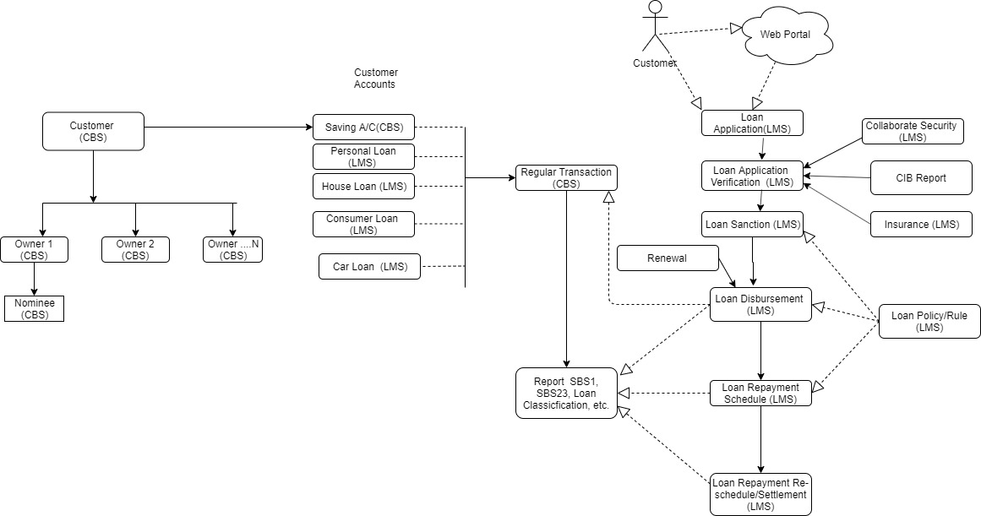

**Loan Approval Workflow Diagram (current phase):**



## 3.6 DB design and DATA DICTIONARY:

In this DB design, all objects will be designed as naztech DB design convention

A few general remarks:

* We want the capability of entering data simultaneously at different levels smoothly Therefore, wherever possible, primary keys will be distinct for different entities. This is mainly done by including id_xxx_key and any other id_xxx_ as required in the primary key.
* The deletion of records in some master tables will lead to integrity problems, as these records may be in use at the branch level. Therefore instead of deleting records, records will be marked as deleted (by setting 0 in is_active column).
* The fields id_xxx_keys are all internal IDs (i.e. only for technical purposes), not visible to the users. All IDs are internally stored as integer.

# 

# 4 FORMS/PAGE DESCRIPTION:

**4.1 Application pages:**

This part contains the description of all pages and reports used in the application. Other buttons or links used in each form or pages will be described in respective pages

## 4.1.1 Id # 001 - Interface Name : Login Form

**Objective: This form will be used to authenticate valid user with permitted access in the application.**

**Layout:**

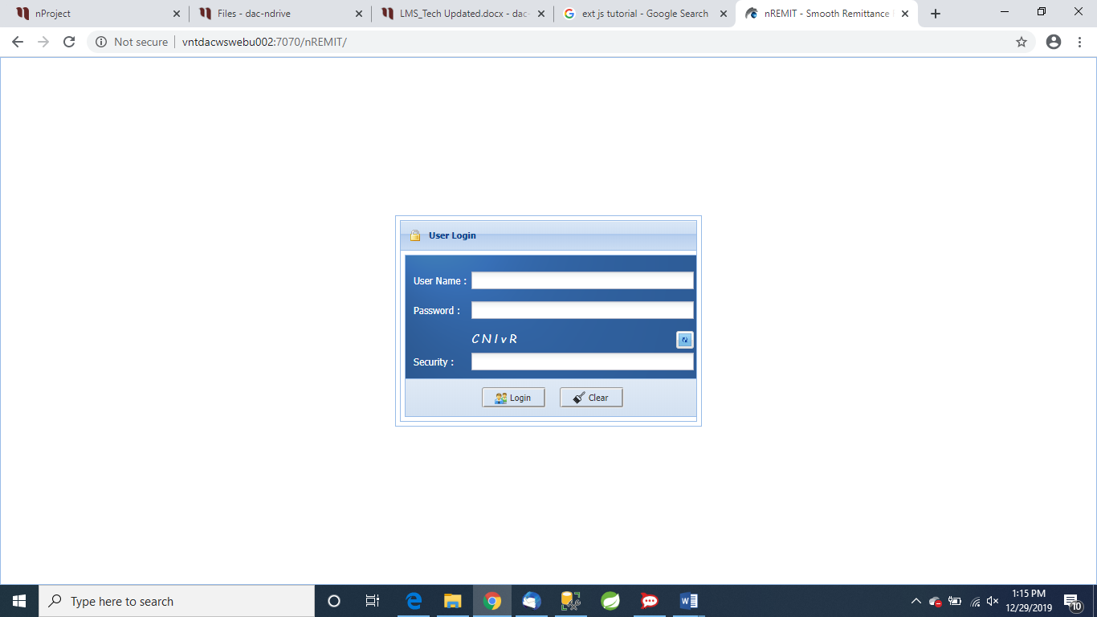

**General Description:**

This form is called during start-up of the application. This login form contains three text boxes and a catchy image.

Text boxes are used to enter user name, password and captcha code. The logged user’s home branch name is added to the form/page’s title and caption. The buttons for which the user has no authorization will be disabled.

### Two Link buttons for “Remember Me” and “Forget Password”

### Technical description:

|  |  |  |
| --- | --- | --- |
| **Item Label caption** | **Component type preferred** | **Details description** |
| User Name | txt |  |
| Password | txt |  |
| Catchy Image | img |  |
| Security Code (Captcha) | txt |  |
| Captcha Refresh | ibtn |  |
| Select Branch | ddl |  |

The current branch is stored in a global variable. DB server’s authorization is used to check whether the user has the necessary access rights. This implies that the user also has to log on to DB.

For head office users, after lost focus of password textbox, an additional dropdownlist with all authorized branches will populated.

Database effects: Check user and role from T_USER and T_ROLE table

### Interface with other forms: The “Main Menu”, “Remember Me”, “Forgot Password” forms are called from this form.

**Action Procedure:**

* Login: Call Main Menu on clicking this button
* Cancel : Clear all textboxes and hold the form clicking this button

**Actors**: The valid user of the respective branch and department who operates as per permission of the section.

**Pre-Condition**: The authorized user has logged in successfully and has access to operate the process.

Post Conditions: None

**Exception conditions:** None

**Remarks**: None

## 4.1.2 Id # 002 - Interface Name : Main Menu

### Objective: A Master page / main menu with several links is used to call other pages and reports.

### Layout:

### Description

This form is called after successful login.The logged user’s home branch name will be displayed to the form/page’s title and caption. The buttons for which the logged user has no authorization, will be disabled.

In Main Menu page several anchorlinks are used to call another form or pages. The link “Change Branch” is used to change the currently loggedbranch. It will call “Change Branch” form. It will be used for head office users. After clicking this link/button, adropdownlist with all authorized branches for the user will pops up. Some additional linksare used to administrate all branches and generate different summary or MIS reports. All controls of the system will be enabled for logged user’s authorization.

### Technical

The current branch is stored in a global variable. Each form will be called using function call.

**Database effects: None**

### Interface with other forms: The other forms are called from this start-up form. No other data is passed to these forms.

Remarks: Administrators have the right to access all branches.

**Action Procedure:**

**Actors**: The valid user of the respective branch and department who operates as per permission of the section.

**Pre-Condition**: The authorized user has logged in successfully and has access to operate the process.

Post Conditions: None

**Exception conditions:** None

**Remarks**: None

**4.1.3 Id # 003 - Interface Name: Employee Info**

Objective: This interface will be used **to enter/change employee information**

**Sample layout:**

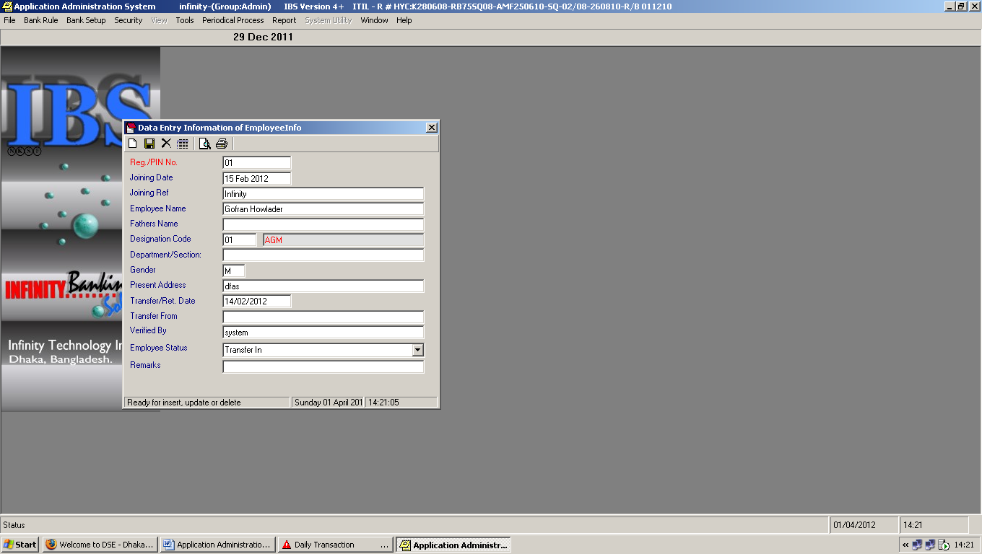

* **Description :**

**This interface will contain the followings:**

|  |  |  |
| --- | --- | --- |
| **Label Name** | **Components to be used** | **Description** |
| Reg/PIN No | txt | Personal Identification Number |
| Joining Date | date |  |
| Joining Ref | txt |  |
| Employee Name | txt |  |
| Fathers Name | txt |  |
| Mothers Name | No |  |
| Spouse Name | No |  |
| Designation Code | ddl |  |
| Department/Section | txt |  |
| Gender | txt |  |
| Present Address | txt |  |
| Transfer/Ref. Date | date |  |
| Transfer From | txt |  |
| Verified By | txt |  |
| Employee Status | ddl |  |
| Remarks | txt |  |

**Action Procedure:**

**Actors**: The valid user of the respective branch and department who operates as per permission of the section.

**Pre-Condition**: The authorized user has logged in successfully and has access to operate the process.

Post Conditions: None

**Exception conditions:** None

**Remarks**: None

**4.1.4** **Id# 004 - Interface Name: Create User**

### Objective:

This form is used to create new users

### Sample Layout:

* **Description:**

|  |  |  |
| --- | --- | --- |
| **User Requirement** | **Existing in Software** | **New Requirement/Remark’s** |
| User Group | ddl |  |
| Reg./ PIN No | txt |  |
| Password Validity | txt | Bangladesh Bank Formula |
| User Id | txt | Increase Field Length 15 Digit & Bangladesh Bank Formula |
| New Password | pwd | Increase Field Length 15 Digit & Bangladesh Bank Formula |
| Confirm Password | pwd | Increase Field Length 15 Digit & Bangladesh Bank Formula |
| Controlled User ID | ddl | Should be add System & Admin user |

**Action Procedure:**

**Actors**: The valid user of the respective branch and department who operates as per permission of the section.

**Pre-Condition**: The authorized user has logged in successfully and has access to operate the process.

Post Conditions: None

**Exception conditions:** None

**Remarks**: None

**4.1,5 Id # 005 - Interface Name: User Access Right**

### Objective:

This form is used to give permission to different users according to individual department and role.

### Sample Layout:

**Interface Name: Loan Account Open**

### Objective:

This form is used to open customer loan accounts for individual loan type. This interface will be used after loan sanctioned and approved.

### Layout:

* **General Description :**

There are two buttons, Save and Exit. Both buttons are standard buttons. It will contain no Cancel button, as this form contains many related Controls and working of the Cancel button might be very confusing.

When loading the form, the branch name is concatenated to the form caption.

### Technical description:

|  |  |  |
| --- | --- | --- |
| **Item Label caption** | **Component type preferred** | **Details description** |
| Customer ID / Name | ddl | Will populate from CBS |
| Account Type Code | ddl | From CBS or LMS…? |
| Loan Account No | txt | Should be auto-generated with pre-formated digit |
| Operation Mode | ddl | Single, join signatory etc. |
| Currency | txt |  |
| Introducer Account No/Name | ddl | Will populate from CBS |
| Account Open Date | dtp |  |
| Ledger No | txt |  |
| Interest Rate | txt | Settled interest rate |
| Loan Type code | ddl |  |
| Loan Detail Type Code | ddl |  |
| Economic Purpose Code | txt | Required for BB |
| Link Account No | ddl | Required if have multiple account |
| Loan Case No | txt |  |
| Loan Due Status | ddl | Current / Past due |
| Sanction No | txt |  |
| Sanction By | txt |  |
| Sanction Date | dtp |  |
| Expire Date | dtp |  |
| Sanction Amount | txt |  |
| Grace Period | txt | In months. Repayment will start after the grace period |
| No Of Installment | txt |  |
| Installment Period frequency |  |  |
| Installment Amount per period | txt |  |
| Margin | txt |  |
| Last Interest Credit Date | dtp | This will be auto updated after each repayment |
| Last Installment receive Date | dtp | This will be auto updated after each repayment |
| Borrower Code | txt | Required for overdraft/advance loan and BB report |
| SBS Code | txt | Required for BB report |
| Statement Frequency | ddl | Yearly, Half-Yearly, Quarterly, Monthly (To sent statement to customer) |

### Database effects

The branch data record can be updated. Records of several related tables can be inserted, updated and deleted. These related tables are:

The current branch is stored in a global variable. DB server’s authorization is used to check whether the user has the necessary access rights. This implies that the user also has to log on to DB.

For head office users, after lost focus of password textbox, an additional dropdown list with all authorized branches will populated.

Database effects: Store data into T_LOAN_ACCOUNT

### Interface with other forms: None

Action Procedure:

**Actors**: The valid user of the respective branch and department who operates as per permission of the section.

**Pre-Condition**: Must have savings account in the CBS.

Post Conditions: None

**Exception conditions:** None

**Remarks**: None

**4.1.6 Id # 006 - Interface Name: Supporting Document Upload**

**Objective**: This interface will be used to upload supporting document for any loan application.

### Sample Layout:

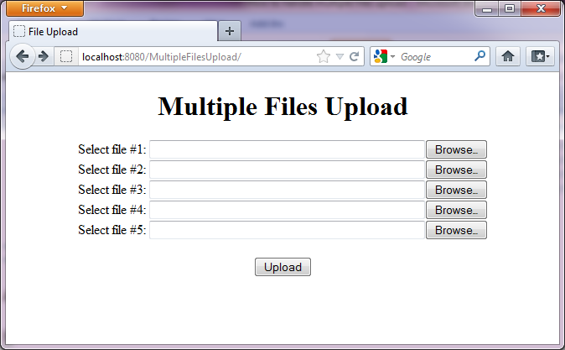

**Description:**

As a list of documents required to process a loan, it is suggested that multiple file uploading process can be better as the following picture. All documents will be stored in a fixed location of the web server. During the upload process, it is suggested that file name will be changed as the following format:

* Loan Type
* Applicant_ID
* Doc-Type
* Upload Date
* Upload Time

For example:

* PersonalLoan-0005_Passpost_20190415_124528
* PersonalLoan-0005_NID_20190415_124528
* PersonalLoan-0005_BirthRegistration_20190415_124528

**Action Procedure:**

**Actors**: The valid user of the respective branch and department who operates as per permission of the section.

**Pre-Condition**: The authorized user has logged in successfully and has access to operate the process.

Post Conditions: None

**Exception conditions:** None

**Remarks**: None

**4.1.7 Id # 007 - Interface Name: Collateral Security**

Objective: This interface will be used to enter collateral security with its value for any loan application.

### Sample Layout:

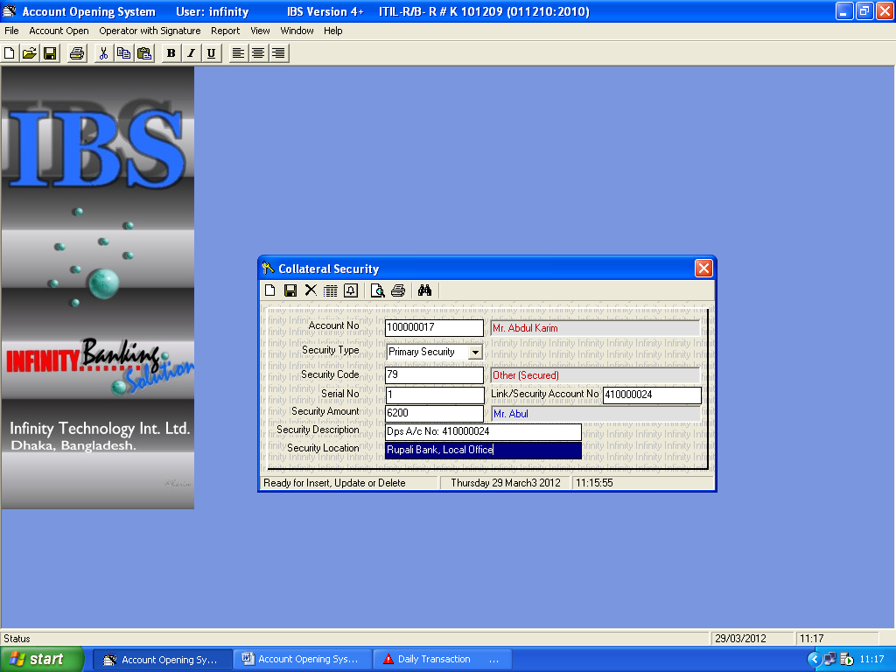Description :

|  |  |  |
| --- | --- | --- |
| **User Requirement** | **Existing in Software** | **New Requirement/Remark’s** |
| Account No/name | ddl | Loan account |
| Security Type | ddl | Primary/secondary security |
| Security Code | ddl | From BB code |
| Serial No | txt |  |
| Link/ Security Account No | ddl | Other savings account |
| Security Amount | txt | After valuating assets as collateral security |
| Security Description | txt |  |
| Security Location | txt | Asset location |

**Action Procedure:**

**Actors**: The valid user of the respective branch and department who operates as per permission of the section.

**Pre-Condition**: The authorized user has logged in successfully and has access to operate the process.

Post Conditions: None

**Exception conditions:** None

**Remarks**: None

**4.1.8 Id # 008 - Interface Name: Guarantor Information**

Objective: This interface will be used to enter Guarantor info for any loan application.

### Sample Layout:

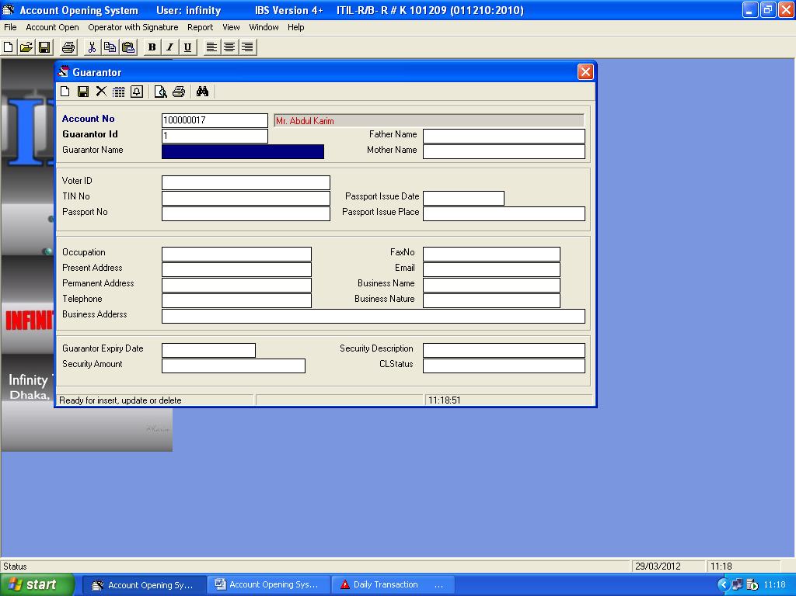

**Description:**

|  |  |  |
| --- | --- | --- |
| **User Requirement** | **Existing in Software** | **New Requirement/Remark’s** |
| Account No/name | ddl |  |
| Guarantor ID | txt |  |
| Guarantor Name | txt |  |
| Father Name | txt |  |
| Mother Name | txt |  |
| National ID | txt |  |
| TIN No | txt |  |
| Passport No | txt |  |
| Passport Issue Date | dtp |  |
| Passport Issue Place | txt |  |
| Occupation | ddl |  |
| Present Address | txt |  |
| Permanent Address | txt |  |
| Telephone | txt |  |
| Business Address | txt |  |
| Fax No | txt |  |
| Email | txt |  |
| Business Name | txt |  |
| Business Nature | txt |  |
| Business Address | txt |  |
| Guarantor Expiry Date | dtp |  |
| Security Amount | txt | If valuable asset are as garranty |
| Security Description | txt | Asset description |

**Action Procedure:**

**Actors**: The valid user of the respective branch and department who operates as per permission of the section.

**Pre-Condition**: The authorized user has logged in successfully and has access to operate the process.

Post Conditions: None

**Exception conditions:** None

**Remarks**: None

**4.1.9 Id # 009 - Interface Name: Insurance Information**

Objective: This interface will be used to enter Insurance info for any loan applicant.

### Sample Layout:

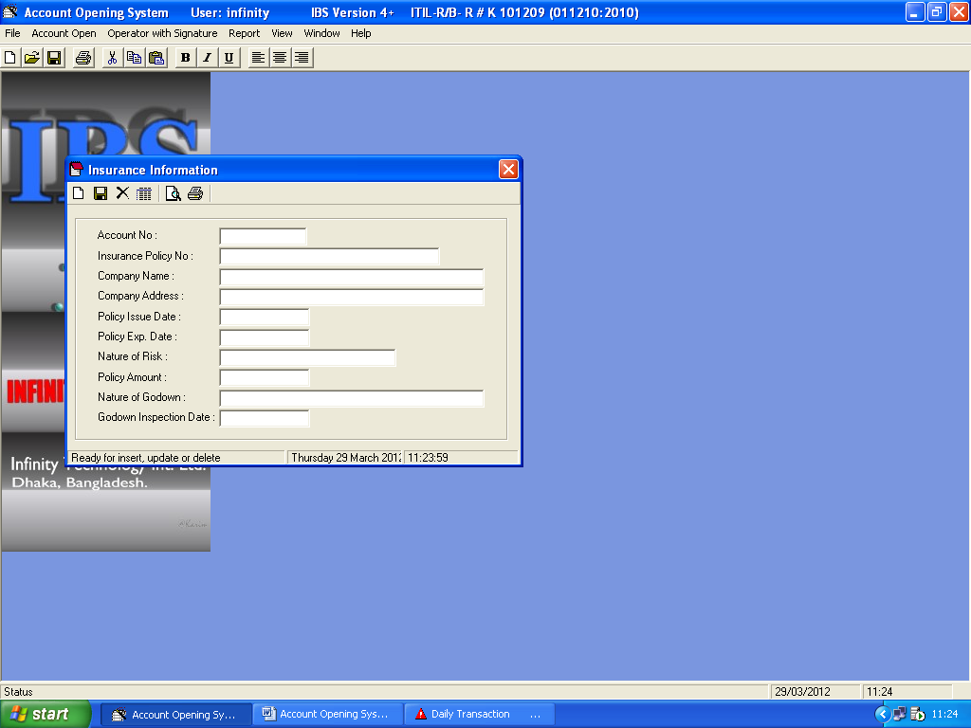

**Description:**

|  |  |  |
| --- | --- | --- |
| **User Requirement** | **Existing in Software** | **New Requirement/Remark’s** |
| Account No | ddl |  |
| Insurance Policy No | txt |  |
| Company Name | txt |  |
| Company Address | txt |  |
| Policy Issue Date | txt |  |
| Policy Expire Date | dtp |  |
| Nature of Risk | txt |  |
| Policy amount | txt |  |
| Nature of Godown | txt |  |
| Godown Inspection Date | dtp |  |

**Action Procedure:**

**Actors**: The valid user of the respective branch and department who operates as per permission of the section.

**Pre-Condition**: The authorized user has logged in successfully and has access to operate the process.

Post Conditions: None

**Exception conditions:** None

**Remarks**: None

**4.1.10 Id # 010 - Interface Name: Document Verification Process**

Objective: This interface will be used to verify attached supporting documents with its original copy from concerned issuing authorities.

### Sample Layout:

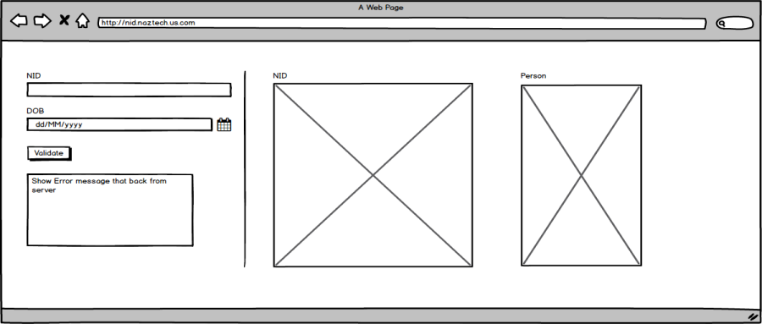

Description:

To verify any application, some of the following supporting documents are attached which are provided by any got agency or autonomous body:

* Nation ID Card
* Valid Passport
* Driving license
* Trade license
* TIN certificate
* VAT certificate
* Import/export license
* Birth Registration certificate
* etc.

Currently the client validates all supporting documents manually. To facilitate this verification process comparing with its original document, web API from providing bodies will be used. In the current phase, only NID will be verified with Election Commission of Bangladesh (ECB) during the approval process. To simplify the process, a web service to be developed. This service will do the followings:

* Scrap NID details from ECB website searching with NID number and Date of Birth
* Store scrapped data as an images. Images will be stored in a physical location and its file name, path, receive date & time will be stored in the application’s DB
* During the verification process, NID data will search from application DB. If found, retrieve data from DB and image from physical location otherwise scrape & load from ECB’s web site.
* There will be a configurable date or days for auto update i.e re-scrape NID data from ECB. An web service will be created to facilitate the auto scrape service
* Also, there will be an option to retrieve from ECB website instantly.
* In the GUI, NID will be displayed at the screen to verify with the attached printed copy of NID

GUI to be developed.

**Action Procedure:**

**Actors**: The valid user of the respective branch and department who operates as per permission of the section.

**Pre-Condition**: The authorized user has logged in successfully and has access to operate the process.

Post Conditions: None

**Exception conditions:** None

**Remarks**: None

**4.1.11 Id # 011- Interface Name: Loan Approval Process**

Objective: This interface will be used to approve any loan application.

### Sample Layout:

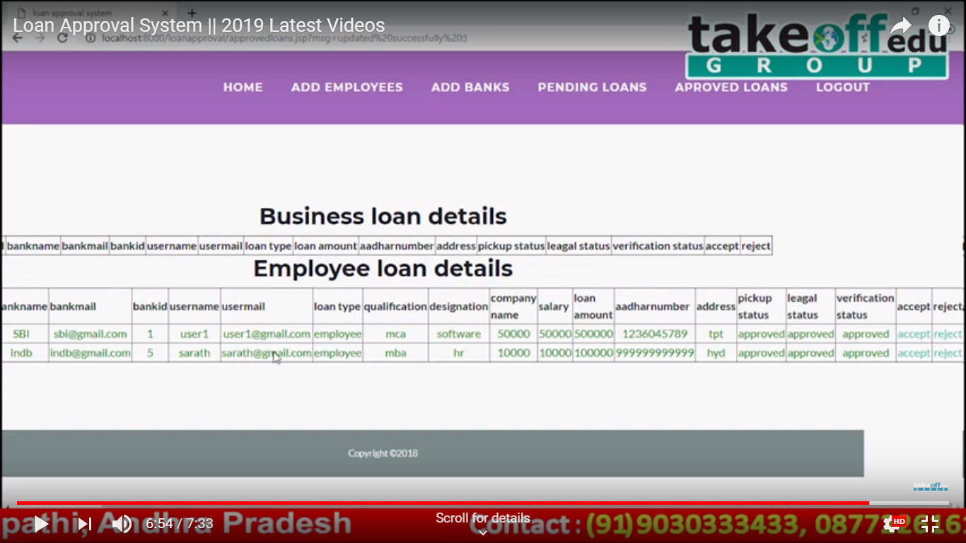

Description:

### Several types of user will login and according to their type, all department’s approval layout will be changed

|  |  |  |
| --- | --- | --- |
| **Label Name** | **Components to be used** | **Description** |
| Applicant ID | txt | Personal Identification Number |
| Applicant Name | txt |  |
| Address | txt |  |
| Phone No | txt |  |
| Email address | txt |  |
| Loan Type | ddl |  |
| Applied Amount | txt |  |
| NID Number | txt |  |
| Collateral Security Value | txt |  |
| SO Approval Status | chk | On Hold/Approve/Reject/Return for more info |
| CAD Approval Status | lbl | On Hold/Approve/Reject/Return for more info |
| BM Approval Status | lbl | On Hold/Approve/Reject/Return for more info |
| CIB Approval Status | lbl | On Hold/Approve/Reject/Return for more info |
| CRM Approval Status | lbl | On Hold/Approve/Reject/Return for more info |

**Action Procedure:**

**Actors**: The valid user of the respective branch and department who operates as per permission of the section.

**Pre-Condition**: The authorized user has logged in successfully and has access to operate the process.

Post Conditions: None

**Exception conditions:** None

**Remarks**: None

**4.1.12 Id # 012 - Interface Name: Loan Policy/Rule (Account Open Rule)**

Objective: This interface will be used to define loan policy for any loan account.

### Sample Layout:

**Description:**

|  |  |  |
| --- | --- | --- |
| **Label Name** | **Components to be used** | **Description** |
| Account Type Code | ddl |  |
| Introducer Validation | chk |  |
| Nominee Validation | chk |  |
| Guarantor Validation | chk |  |
| Coll.security Validation | chk |  |
| Insurance Validity | chk |  |
| Interest Free | chk |  |
| IC Free | chk |  |
| Excise Duty Free | chk |  |
| Service Charge Free | chk |  |
| Other Charge Free | chk |  |
| Levy Charge Free | chk |  |
| Grace Period | chk |  |
| LinkAccType Code | ddl |  |

**Action Procedure:**

**Actors**: The valid user of the respective branch and department who operates as per permission of the section.

**Pre-Condition**: The authorized user has logged in successfully and has access to operate the process.

Post Conditions: None

**Exception conditions:** None

**Remarks**: None

**4.1.13 Id # 013 - Interface Name: Loan Interest Rate Setup**

### Objective: This form is used to setup general I interest rate applicable for all if not specified..

### Sample Layout:

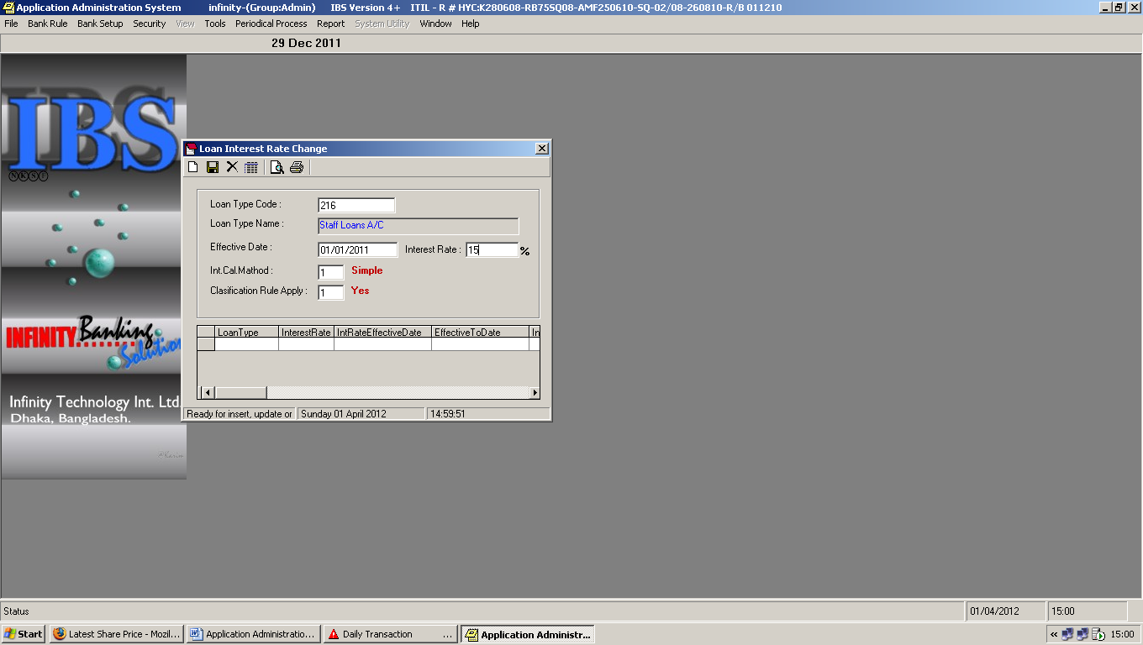

|  |  |  |
| --- | --- | --- |
| **Label Name** | **Components to be used** | **Description** |
| Loan Type Code | txt |  |
| Loan Type Name | ddl |  |
| Effective Date | dtp |  |
| Interest Rate | txt |  |
| Int. Cal. Method | ddl |  |
| Classification Rule Apply | ddl |  |

**Action Procedure:**

**Actors**: The valid user of the respective branch and department who operates as per permission of the section.

**Pre-Condition**: The authorized user has logged in successfully and has access to operate the process.

Post Conditions: None

**Exception conditions:** None

**Remarks**: None

**4.1.14 Id # 014 - Interface Name: Contractual Loan Interest Rate Setup**

### Objective: This form is used to setup special/contractual interest rate for all type of loan..

### Sample Layout:

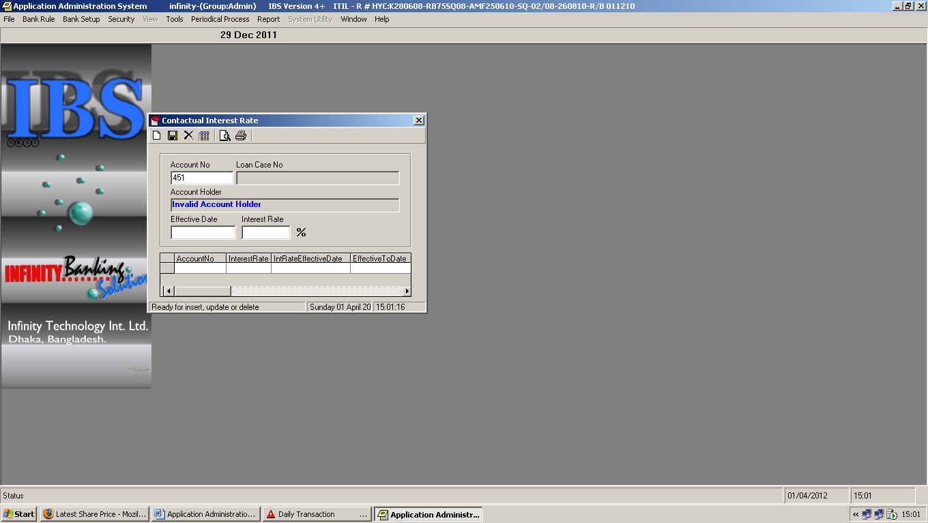

**Description:**

|  |  |  |
| --- | --- | --- |
| **Label Name** | **Components to be used** | **Description** |
| Account No | ddl |  |
| Effective date | dtp |  |
| Interest Rate | txt |  |

**Action Procedure:**

**Actors**: The valid user of the respective branch and department who operates as per permission of the section.

**Pre-Condition**: The authorized user has logged in successfully and has access to operate the process.

Post Conditions: None

**Exception conditions:** None

**Remarks**: None

**GENERATING REPORTS:**

Presently, only standard reports will be developed. However, in a later stage more management reports can be added easily. The following Reports will be generated during this phase